***Question 1.WAP in C for Implementation of DFA that accepts all even integers only in the form of binary strings.***

*Sub: FLAT Lab Date :14-Dec-20*

*Submitted by Akash Kumar reg:1801289021*

***ASSIGNMENT 3***

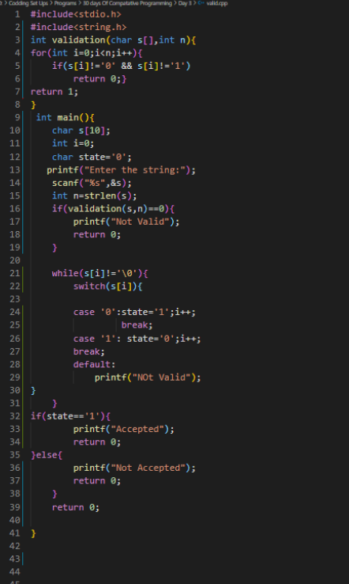

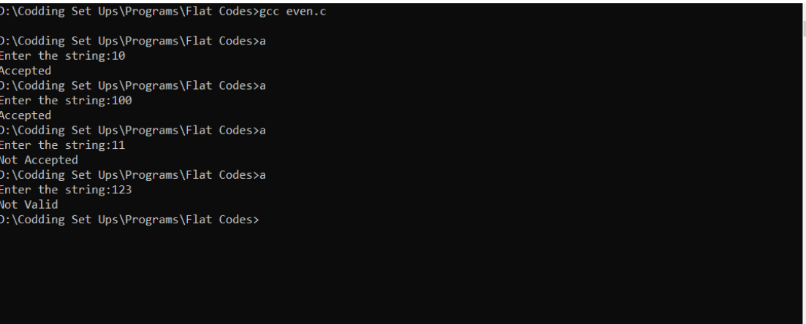

***Question 2.WAP in C for Implementation of DFA that accepts all odd integers only in the form of binary strings.***

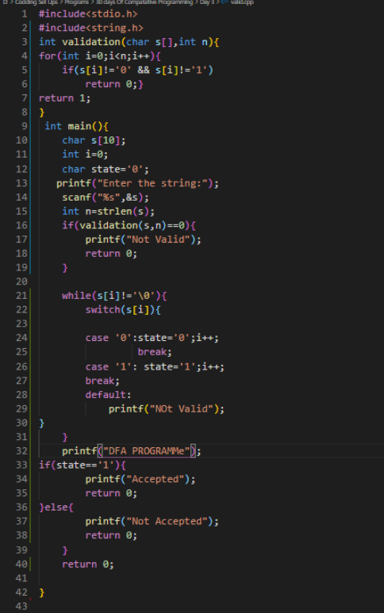

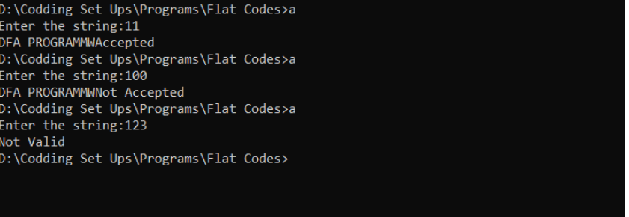

*Name: Akash Kumar*

*Branch CSE-A*

*Roll: -06*

*RegNo:1801289021*